

**UNIVERSITY OF ASIA PACIFIC**

**Department of Computer Science & Engineering**

|  |
| --- |
| SOHO |

**Course Code :** CSE 320

**Course Title :** Computer Networks Lab

**Submitted by: Submitted To: Name :** Sheikh Nafez Sadnan Md. Akhtaruzzamman Adnan **Reg. No. :** 20101106 Assistant Professor

**Roll No. :** 106 Department of CSE

**Section :** B (2) University of Asia Pacific

**Project Small Office Home Office (SOHO) Case Study and Requirements:**  
XYZ company is a fast-growing company in Eastern Australia with more than 2 million customers globally. The company deals with selling and buying of food items, which are basically operated from the headquarters. The company is intending to open a branch near the local village Bonalbo. Thus, the company requires young IT graduates to design the network for the branch. The network is intended to operate separately from the HQ network. Being a small network, the company has the following requirements during implementation;

* One router and one switch to be used (all CISCO products).
* 3 departments (Admin/IT, Finance/HR and Customer service/Reception).
* Each department is required to be in different VIANS.
* Each department is required to have a wireless network for the users.
* Host devices in the network are required to obtain IPv4 address automatically.
* Devices in all the departments are required to communicate with each other.

Assume the ISP gave out a base network of 192.168.1.0, you as the young network engineer who has been hired, design and implement a network considering the above requirements.

**Technologies Implemented:**

1. Creating a Simple Network using a Router and Access Layer Switch.
2. Connecting Networking devices with Correct cabling.
3. Creating VLANs and assigning ports VLAN numbers.
4. Subnetting and IP Addressing.
5. Configuring Inter-VLAN Routing (Router on a stick).
6. Configuring DHCP Server (Router as the DHCP Server).
7. Configuring WLAN or wireless network (Cisco Access Point).
8. Host Device Configurations.
9. Test and Verifying Network Communication.

How to implement **SOHO**

**Step-1:** Open a project in Cisco Packet Tracer.Take a router, printer, access point & PC from the drop-down menu. The amount of these equipment’s depends on the architecture of the project.

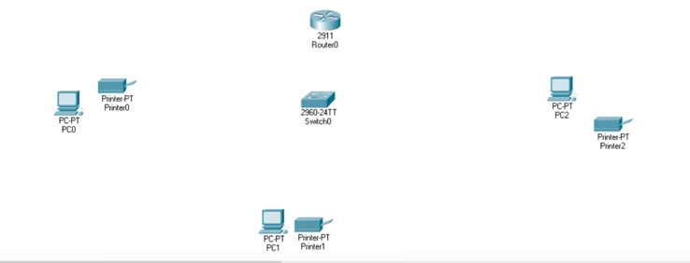

**Step-2:** Rename the equipment’s to avoid confusion.

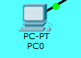

**Step-3:** Choose wires and give connections.

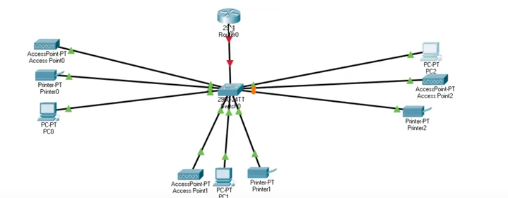

**Step-4:** Give section names and add colors.

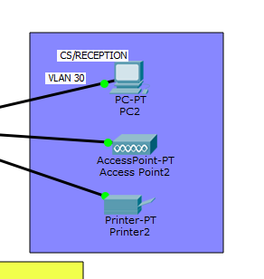

**Step-5:** Give network ID subnet mask.

For admin/IT: **192.168.1.0/26**

For Finance/HR: **192.168.1.64/26**

For CS/Reception: **192.168.1.128/26**

**Step-6:** Configure the VLAN. Go to switch then terminal and write down-

*enable*

*configure terminal*

*int range fa0/2-4*

*switchport mode access*

*switchport access vlan 10*

Similar process for other ports:

*enable*

*configure terminal*

*int range fa0/5-7*

*switchport mode access*

*switchport access vlan 20*

*enable*

*configure terminal*

*int range fa0/8-10*

*switchport mode access*

*switchport access vlan 30*

then,

*do write*

*exit*

*do show start*

Interfaces will show-

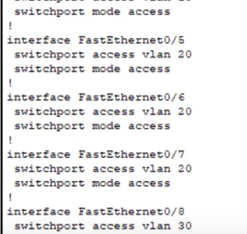

**Step-7:** Implement the access points-

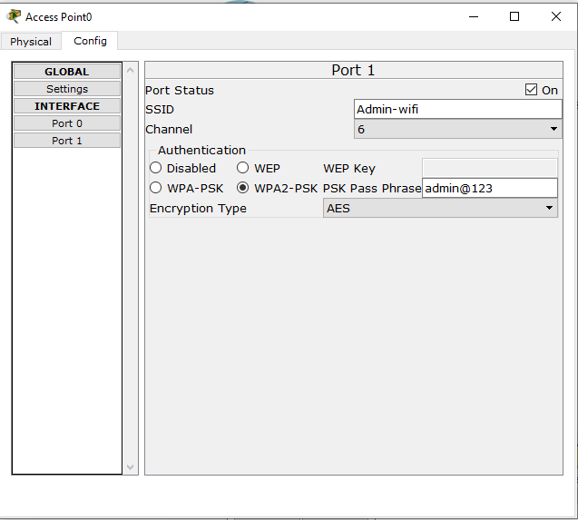

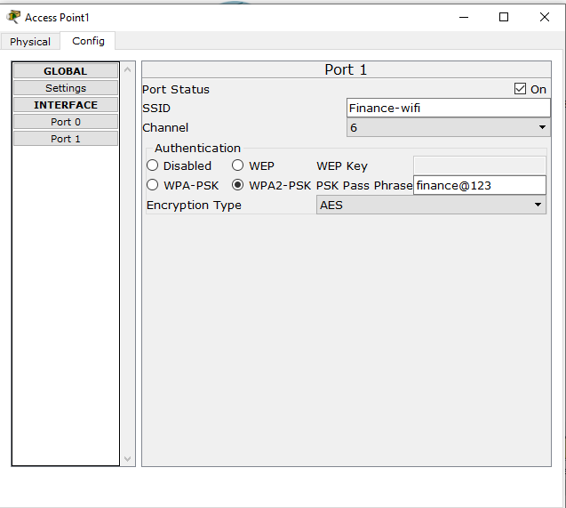

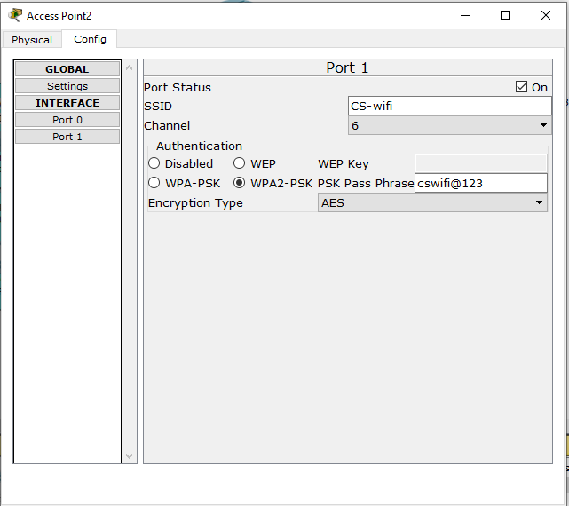

**Step-8:** Configure the router. Go to terminal and write-

*int fa 0/1*

*switchport mode trunk*

*do write*

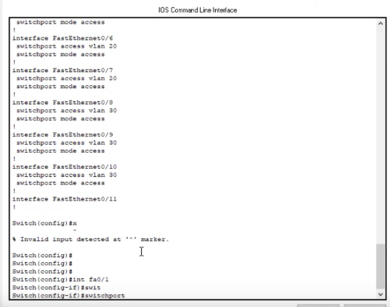

**Step-9:** Configure the remaining router configuration. Go to terminal again and write-

*enable*

*configure terminal*

*int gig0/0*

*no shut*

*do write*

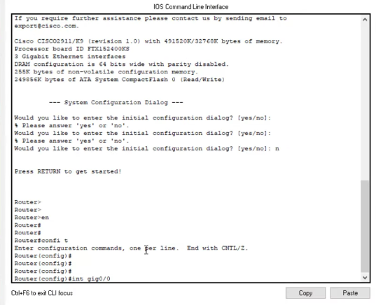

**Step-10:** Configure inter VLAN routing and DHCP server. Starting with creating sub interface, Go to router terminal and write-

*int gig0/0.10*

*encapsulation dot1Q 10*

*ip address 192.168.1.1 255.255.255.192*

*exit*

*int gig0/0.10*

*encapsulation dot1Q 20*

*ip address 192.168.1.65 255.255.255.192*

*exit*

*int gig0/0.30*

*encapsulation dot1Q 30*

*ip address 192.168.1.129 255.255.255.192*

*exit*

*do show start*

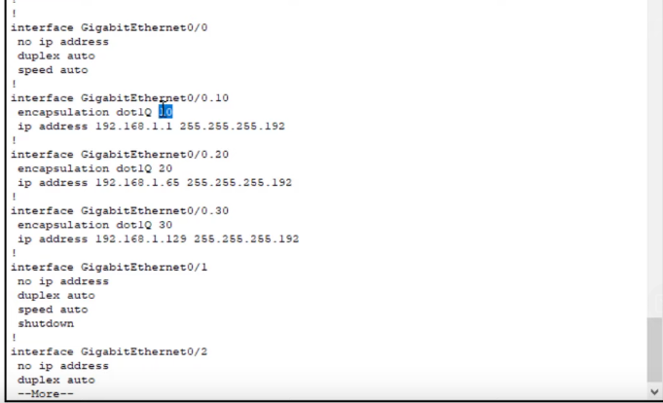

**Step-11:** Configure DHCP server. Starting with creating sub interface, Go to router terminal and write-

*service DHCP*

*dhcp pool Admin-pool*

*network 192.168.1.0 255.255.255.192*

*default-router 192.168.1.1*

dns-server *192.168.1.1*

*domain-name Admin.com*

*exit*

Similarly create another pool-

*service DHCP*

*dhcp pool Finance-pool*

*network 192.168.1.64 255.255.255.192*

*default-router 192.168.1.65*

dns-server *192.168.1.65*

*domain-name Finance.com*

*exit*

Similarly create another pool-

*service DHCP*

*dhcp pool CS-pool*

*network 192.168.1.128 255.255.255.192*

*default-router 192.168.1.129*

dns-server *192.168.1.129*

*domain-name CS.com*

*exit*

*do write*

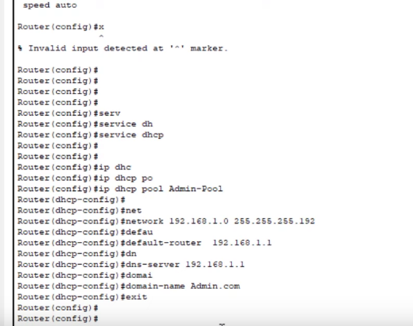

**Step-12:** Test communication. Select DHCP for PC and access points.

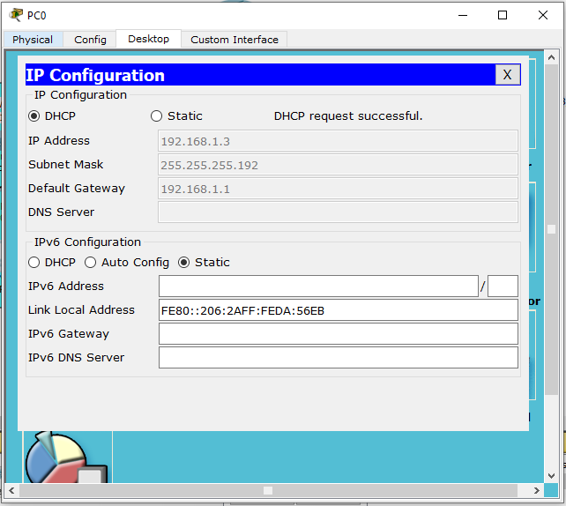

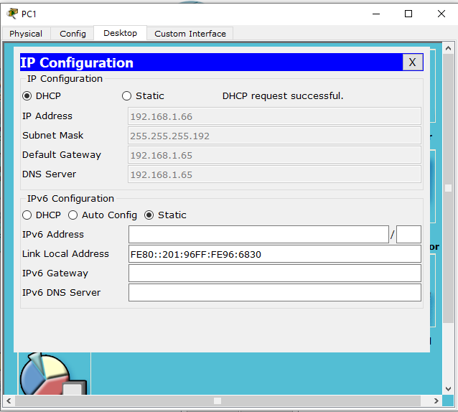

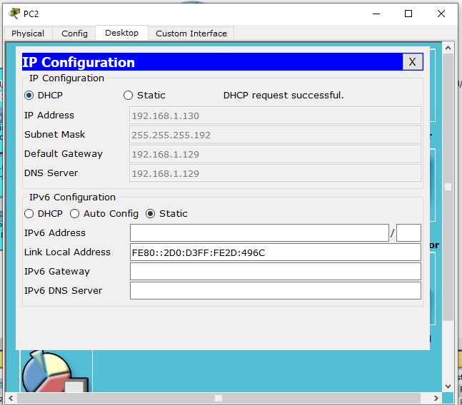

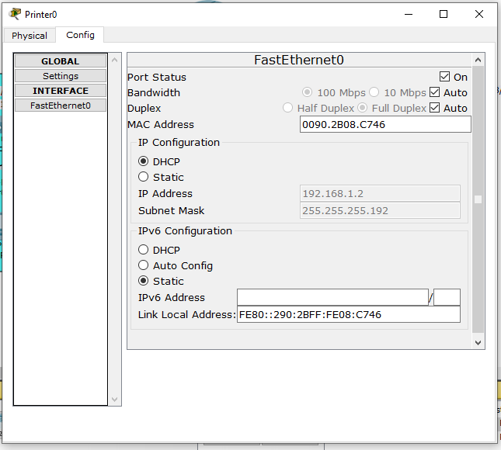

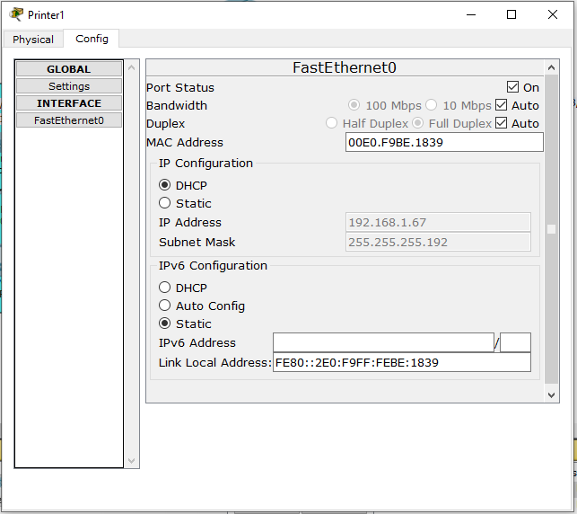

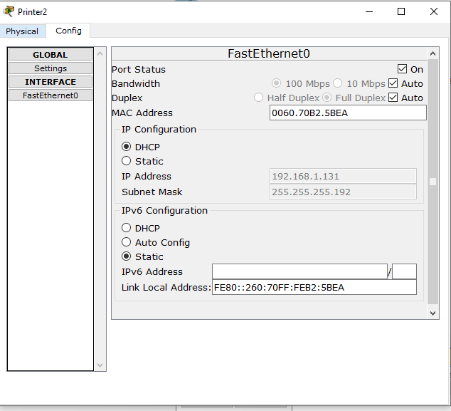

**Step-13:** Pick a smartphone and configure it-

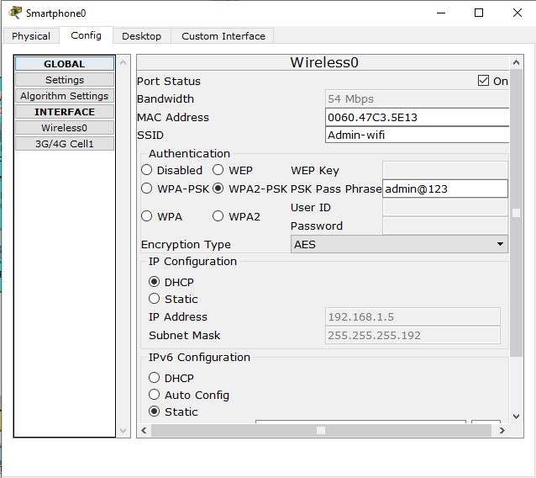

DHCP request is successful-

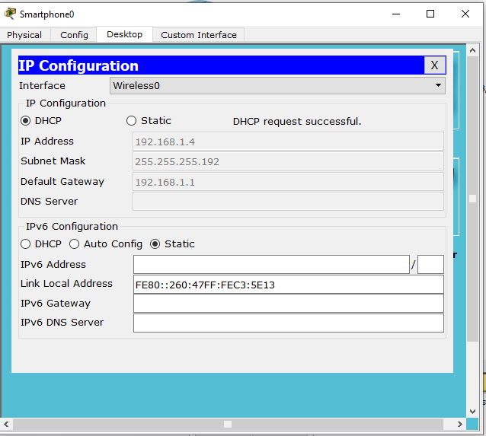

Now the smartphone is connected-

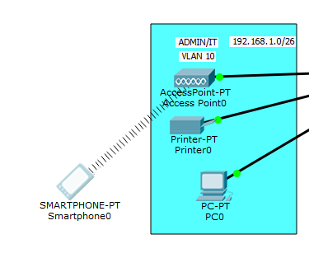

Similarly, take a laptop and configure it-

Turn off the laptop, remove existing and add WPC300N the turn on it-

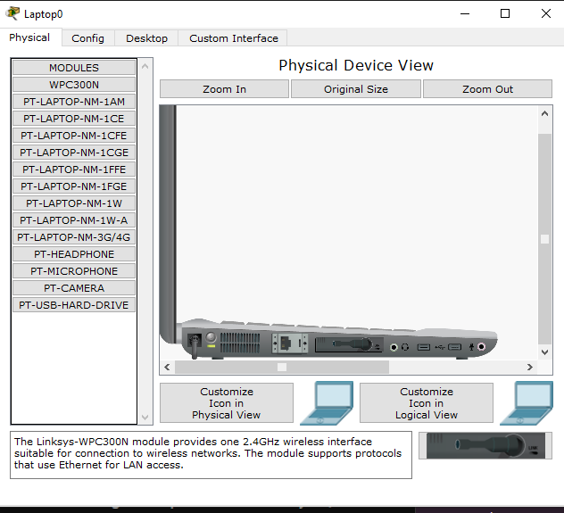

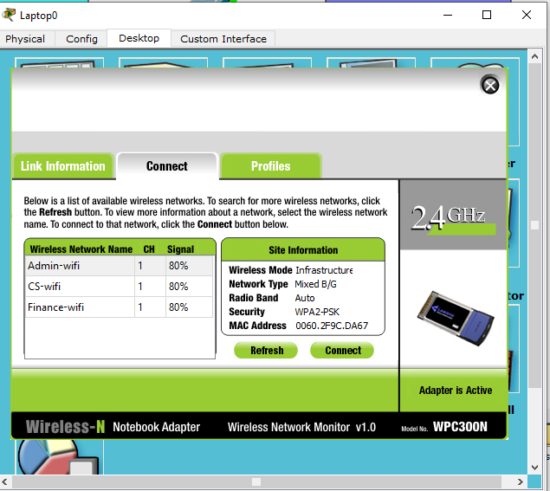

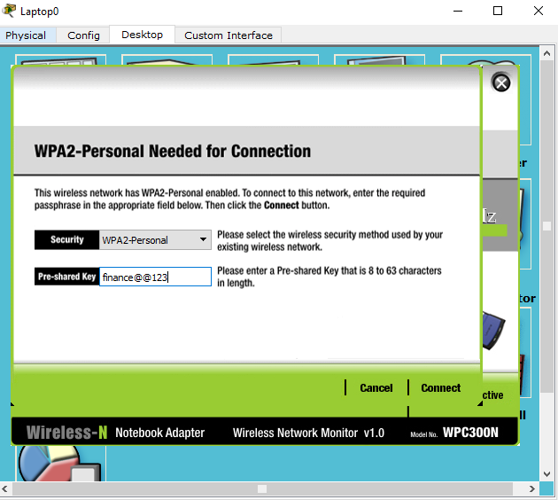

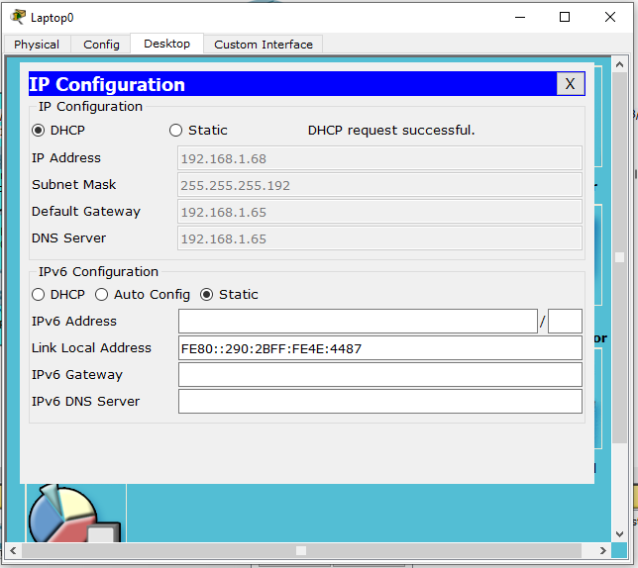

Laptop is connected-

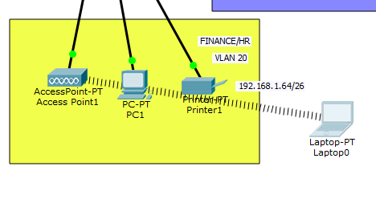

Similarly, connect a tab-

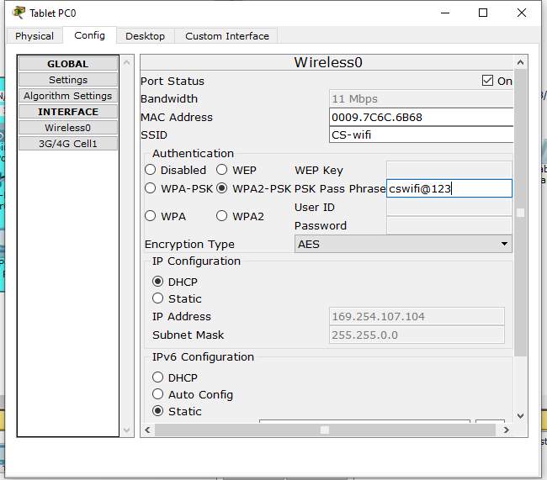

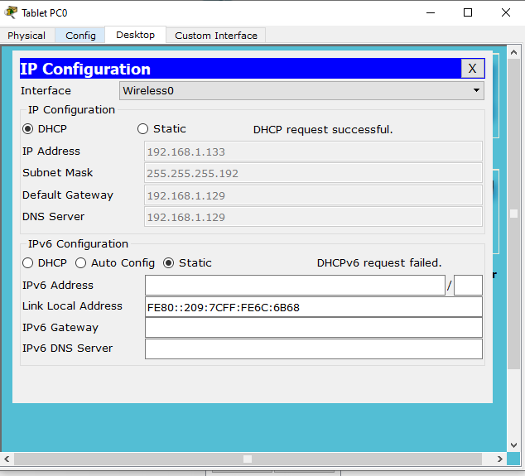

Tab is connected-

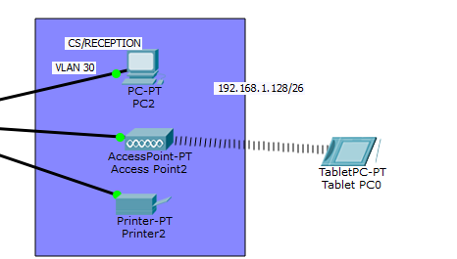

**Step-14:** Test communication. It should succeed-

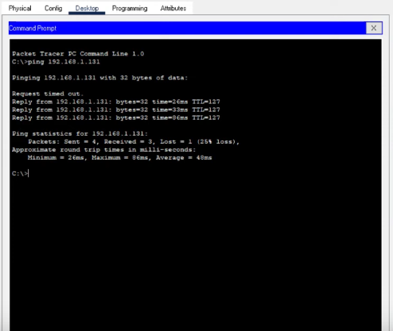

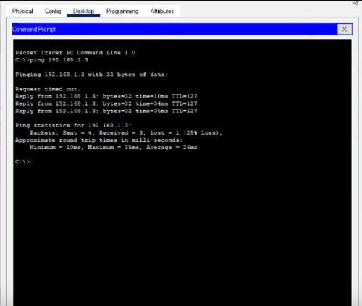

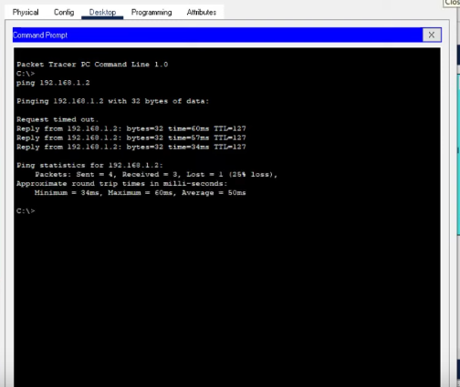

**Overall screenshot of the whole architecture-**

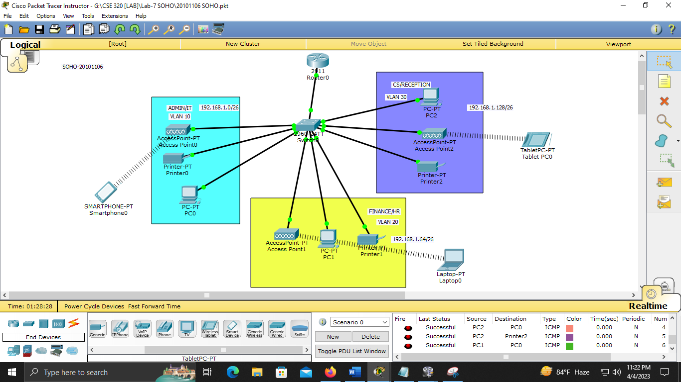

Detailed view-

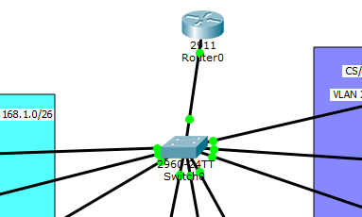

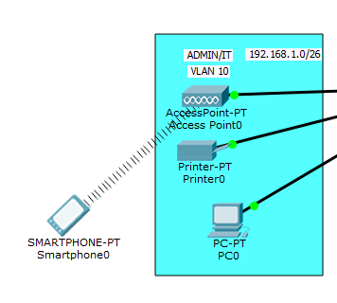

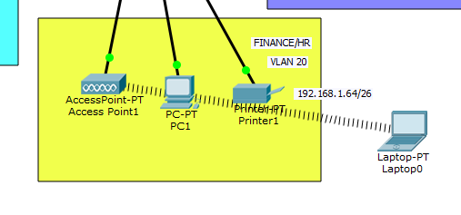

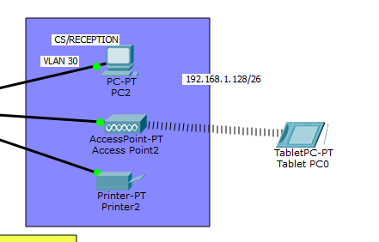

---------------------------THANK YOU FOR READING--------------------------